**Coding practice Problems:** 11.11.2024   
 **Name: VAITHIYANATHAN T   
 Dept :CSE**

**1. 0-1 knapsack problem**

**CODE :**

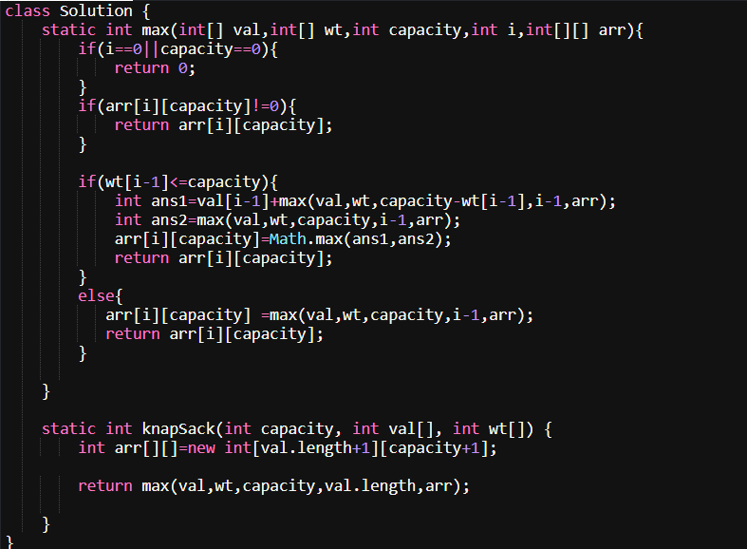

Output:

4

1 2 3

4 5 1

Your Output:

3

Expected Output:

3

TIME Complexity : O(n*capacity)

Space Complexity : O(n*capacity)

2. Floor in sorted array

CODE: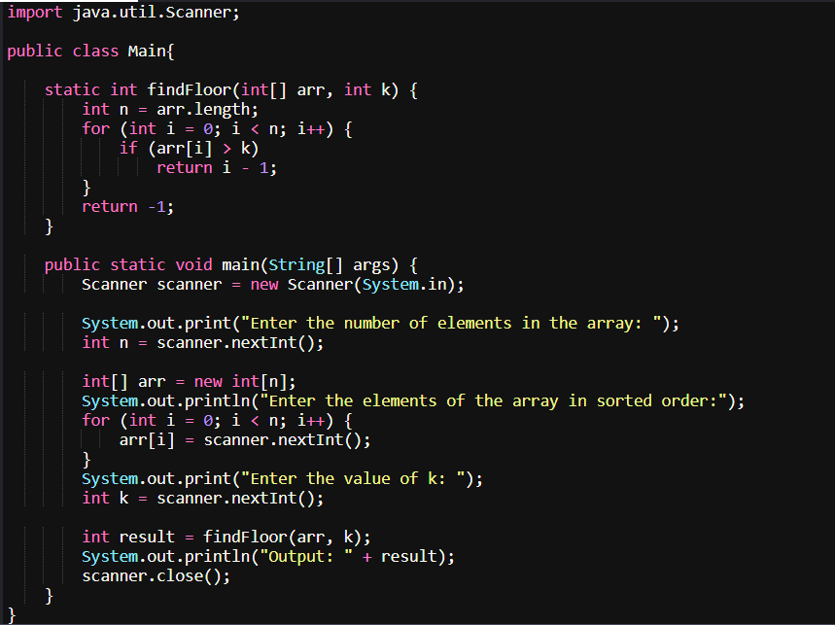

OUTPUT:

Enter the number of elements in the array: 3

Enter the elements of the array in sorted order:

1 2 3

Enter the value of k: 4

Output: -1

Time Complexity : O(n)

Space Complexity: O(1)

3. Check Equal Arrays

CODE:

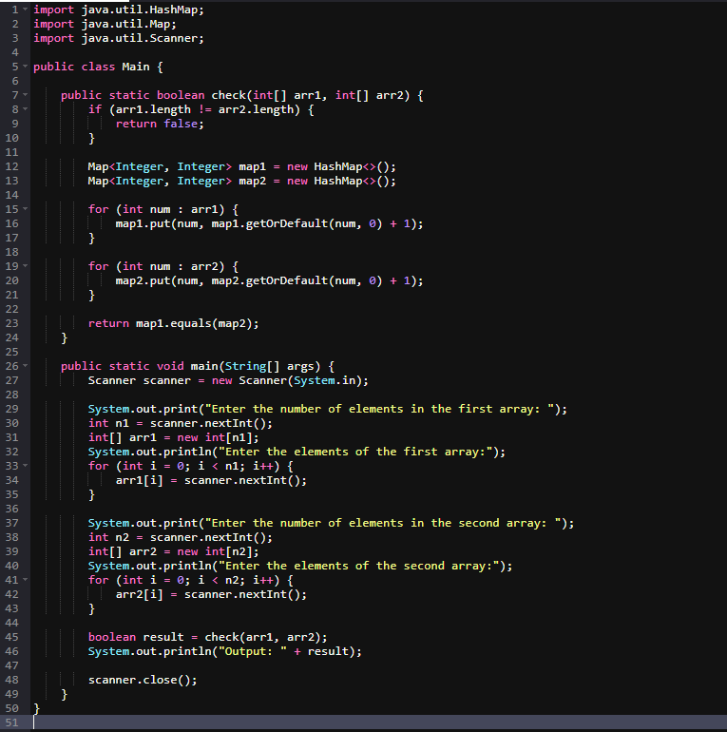

Output:

Enter the number of elements in the first array: 4

Enter the elements of the first array:

1 3 5 2

Enter the number of elements in the second array: 4

Enter the elements of the second array:

1 2 3 4

Output: false

Time Complexity: O(N)

Space Complexity : O(N)

4. Palindrome linked list

CODE:

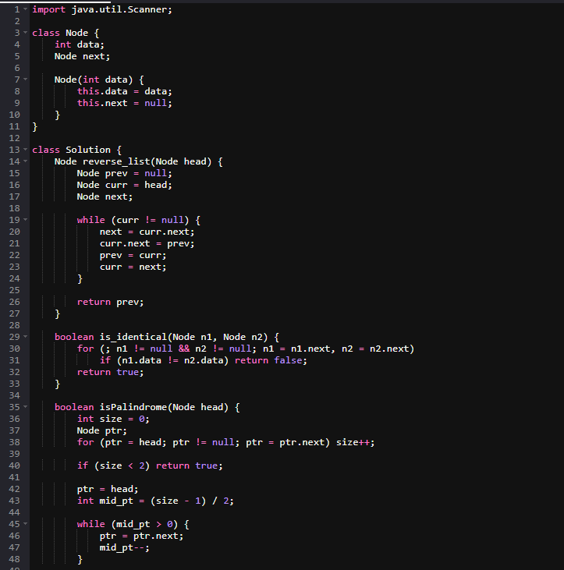  
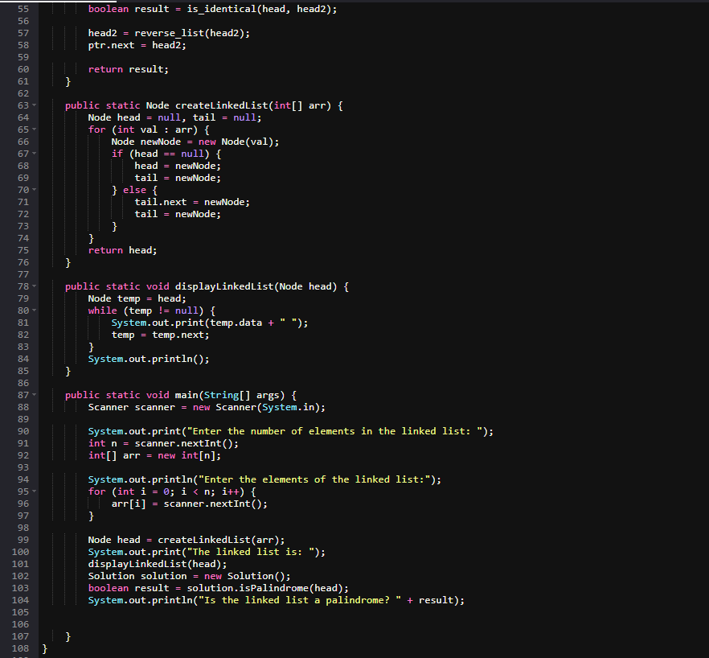

Output:

Enter the number of elements in the linked list: 5 Enter the elements of the linked list: 1 2 3 2 1 The linked list is: 1 2 3 2 1 Is the linked list a palindrome? true

Time Complexity: O(n)

Space Complexity : O(1)

5 . Balanced Tree Check

CODE:  
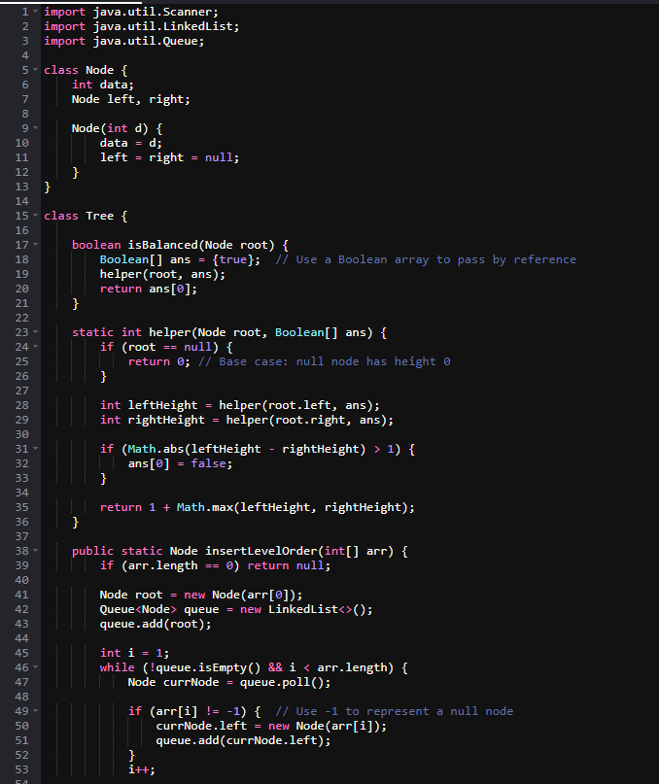  
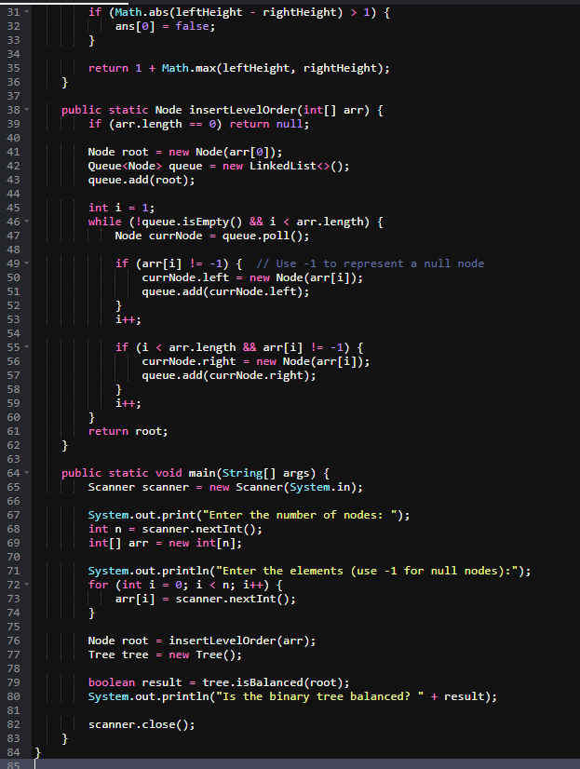

Output:

Enter the number of nodes: 7

Enter the elements (use -1 for null nodes): 1 2 3 4 5 -1 -1

Is the binary tree balanced? True

Time Complexity : O(N)  
Space Complexity : O(h)

5. Triplet sum

CODE:  
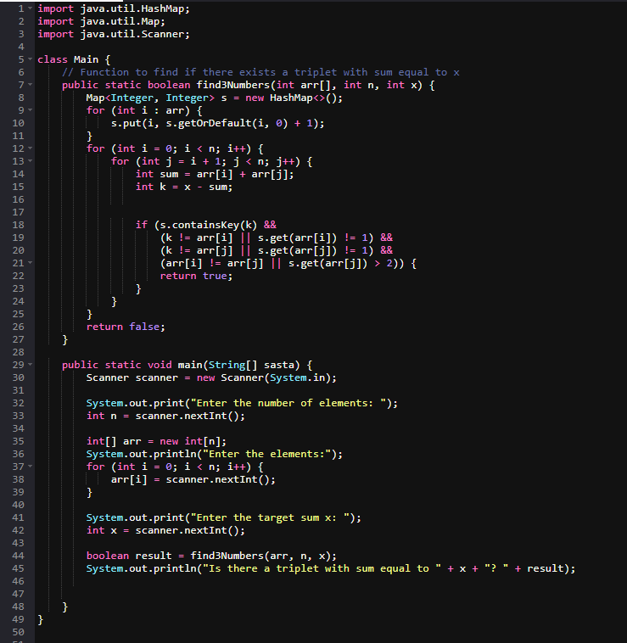

Output:

Enter the number of elements: 3

Enter the elements:

1 3 5

Enter the target sum x: 4

Is there a triplet with sum equal to 4? False

Time Complexity: O(N**2)

Space Complexity : O(n)